**Low Fi Prototype**

I designed my paper prototype similarly to the rest of my website, but I wanted the cart page to be more minimalist and simple than the image-focused rest of my website.

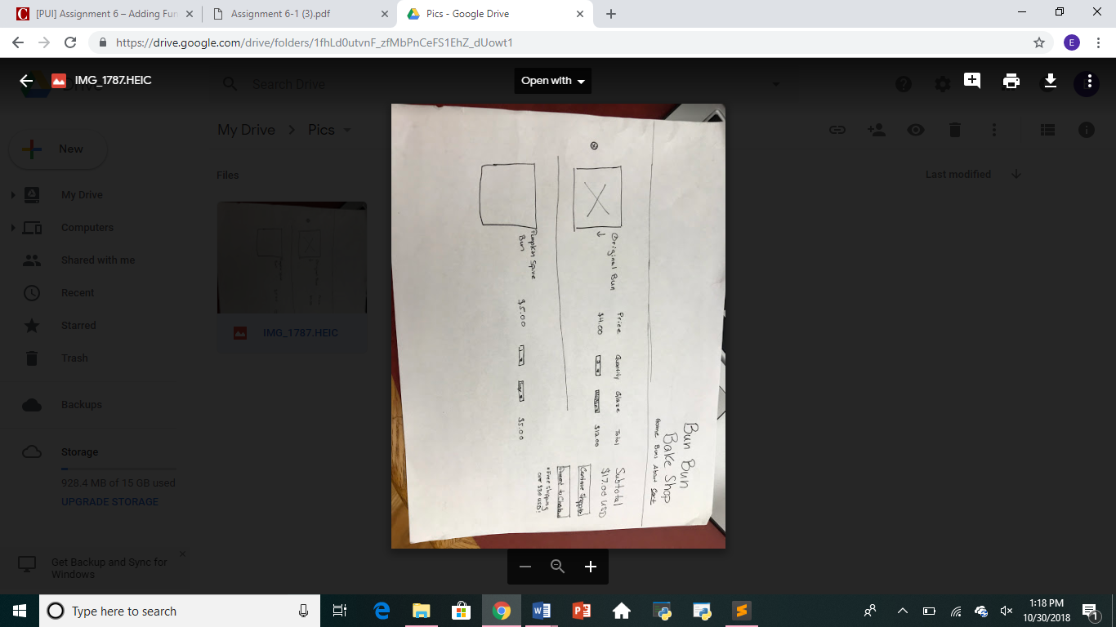

**High Fi Prototype**

<https://invis.io/QHO5H84TEUV#/328263708_Assignment_3_Layouts-pdf_2>

I added to my original high fi prototype, but the style of the cart page reflects the new style of my real site. From my original prototype, my real site has an updated top image, and the nav bar is all on one line. Overall I think the new design is smoother and works better in practice.

**Reflection**

*\*\*note: the cart functionality is only set up for the original bun*

This assignment was incredibly challenging because 1) I have never used JavaScript. 2) I didn’t know how to write my HTML and CSS originally that it worked well with JavaScript so I had to go backwards and fix some, and 3) I didn’t know what to do, so it was really hard to figure out what I was doing wrong. My final product isn’t perfect; there are a lot of cosmetic things to work on in another iteration, but I’m very proud of the functionality I was able to learn and implement. I also had a difficult time switching between JavaScript and JQuery. For example, when I was adding items to the cart, I used appendChild(), but couldn’t figure out why it wasn’t working, but apparently I was just supposed to use append() because of JQuery.

I would never have been able to overcome these challenges or do the assignment at all without the SSUI students, my friends, and the TAs. Big shout out to Asit for holding a big JavaScript session for all of us in the lab. Learning to effectively debug and use Google also helped me figure out how do complete the assignment.